**JAYPEE INSTITUTE OF INFORMATION TECHNOLOGY**

A 10, A Block, Block A, Industrial Area, Sector 62, Noida, Uttar Pradesh 201309

# DSW Project



**Prepared By :-**

* Ananya Mittal (21103305)
* Ashmeet Mittal (21103311)
* Juhi Sharma (21103294)
* Manya Jain (21103313)

**Batch :-** B9

## ****Acknowledgement****

I would like to express my special thanks to my DSW teacher, Mrs. Indu Chawla who gave me the opportunity to do this wonderful project on the topic “UNIFACE TEST LABS”, which also helped me in doing a lot of Research and I came to know about various concepts.

Secondly, I would also like to thank my parents and friends who helped me a lot in finishing this project within the limited time.

# **\*\*\*\*\*Uniface Test Labs\*\*\*\*\***

In the era of rising entrepreneurship, there is a rat race happening between various rising startups and other developing companies who are urging to get their new products certified as soon as possible. In order to fulfill their urge and demand, we have planned to make a real-life project in which we will be making a website using HTML, CSS, JavaScript while connecting them to the backend i.e. MySQL via PHP. The title of our project is “Uniface Test Labs”. The main idea is to connect the two important ends in the process of certification i.e., the companies who give certification to different range of products and the startups or the companies who are seeking to get their products certified as soon as possible. The website will be having the data of those companies who offer certification like ESCO, NABL. etc. Our idea is somewhat similar to that of Amazon, but our domains of work is totally different. We are trying to provide all the certification which the companies/startups will be needing to make their product branded in one go.

## ******ER Diagram******

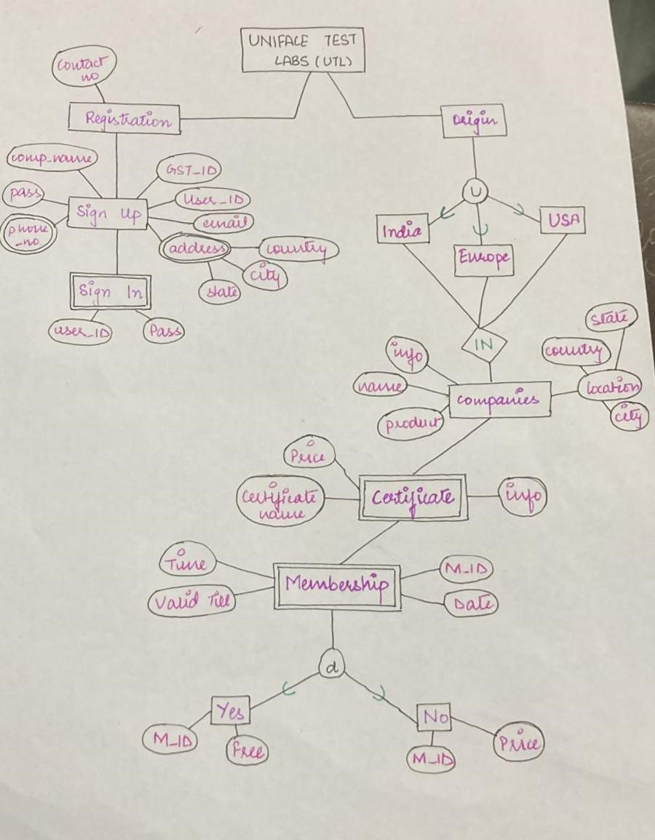

**\*\*\*\*\*Relational Diagram\*\*\*\*\***

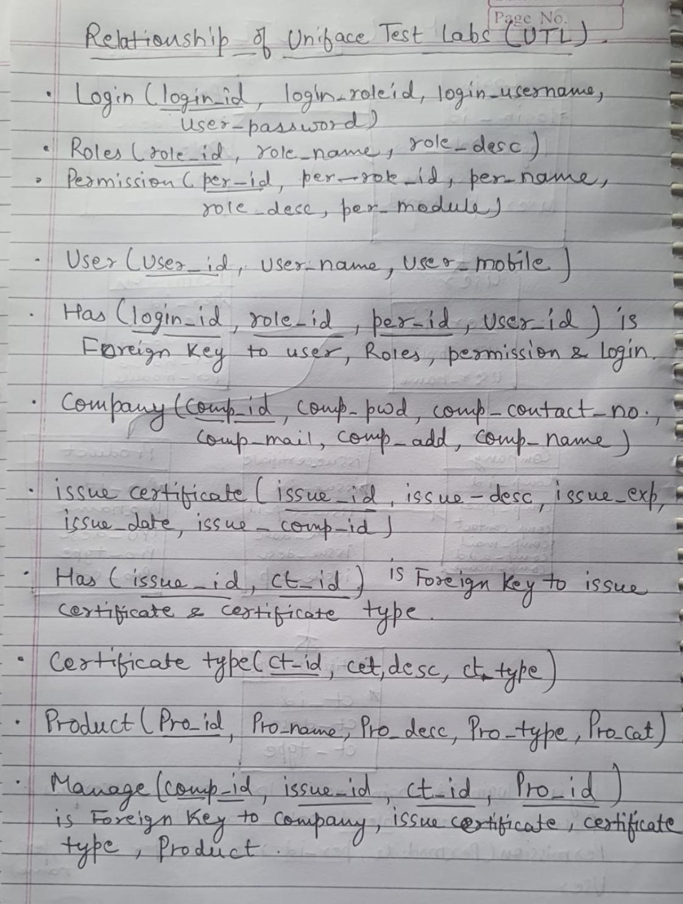

## ***Output Screenshots***

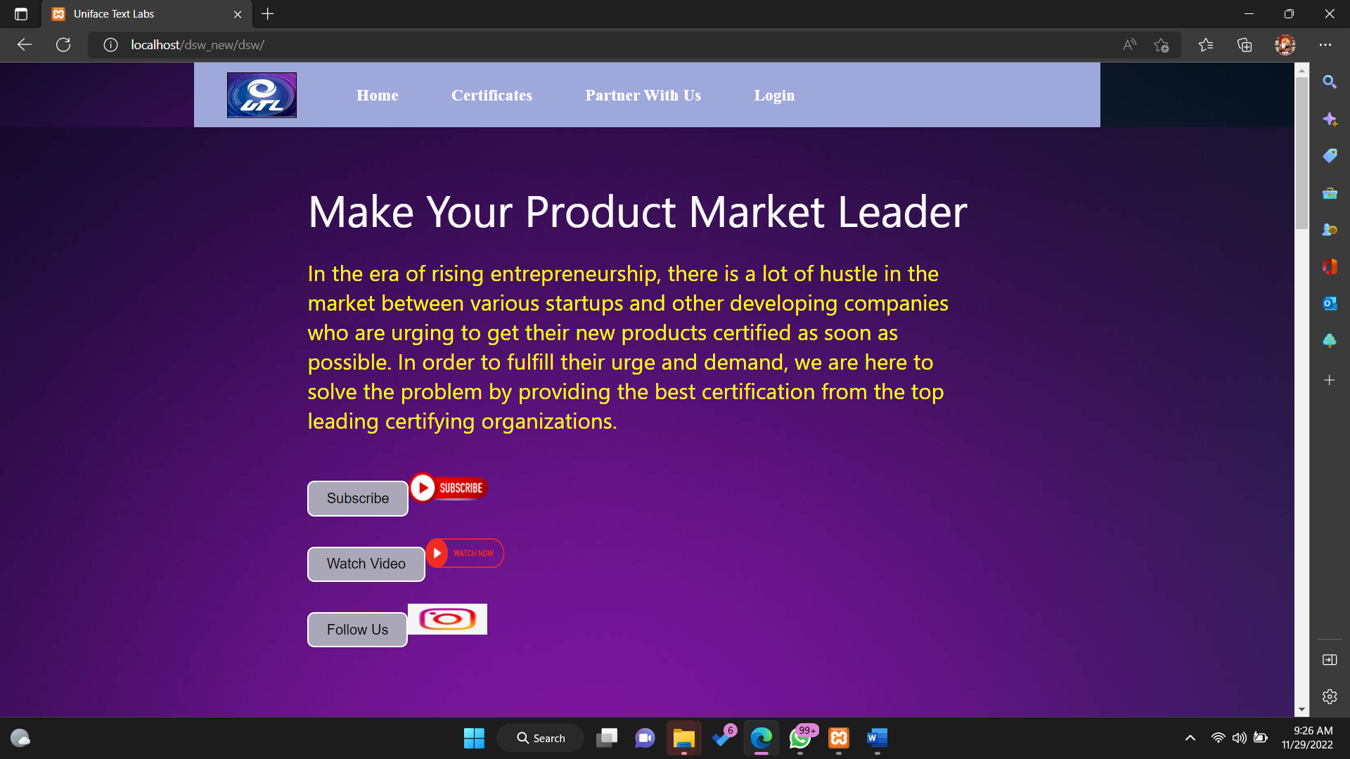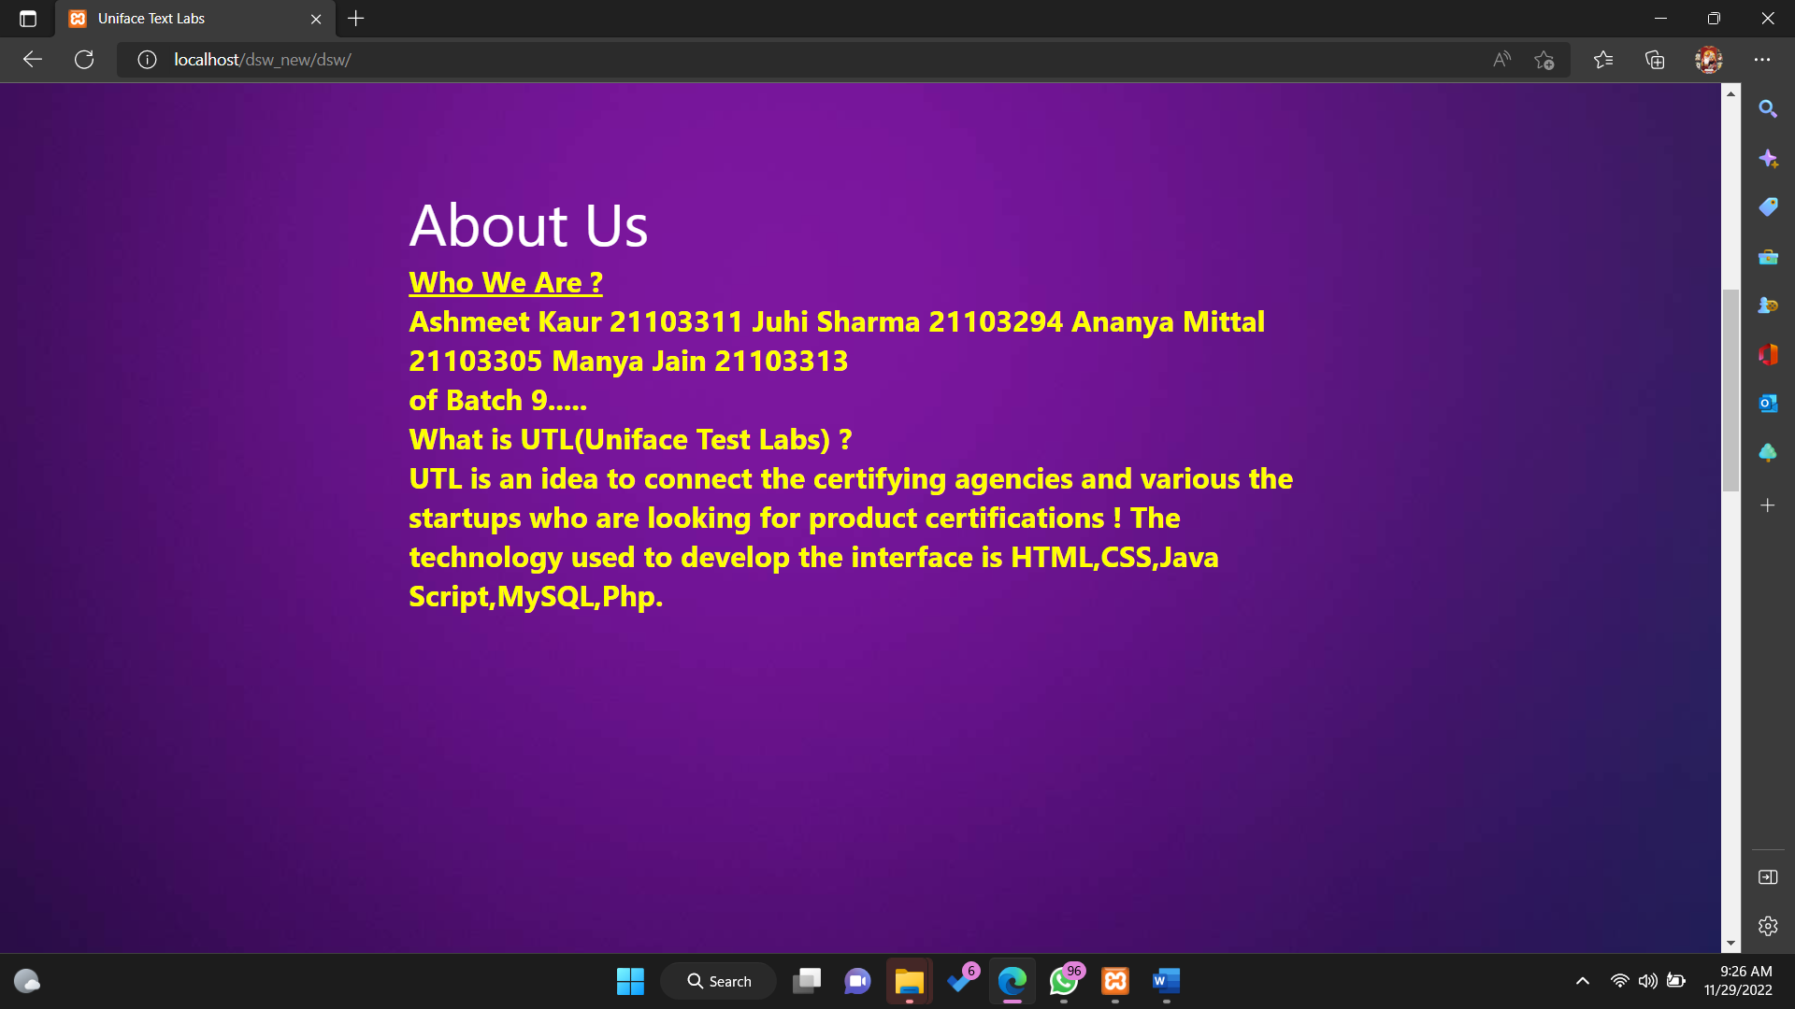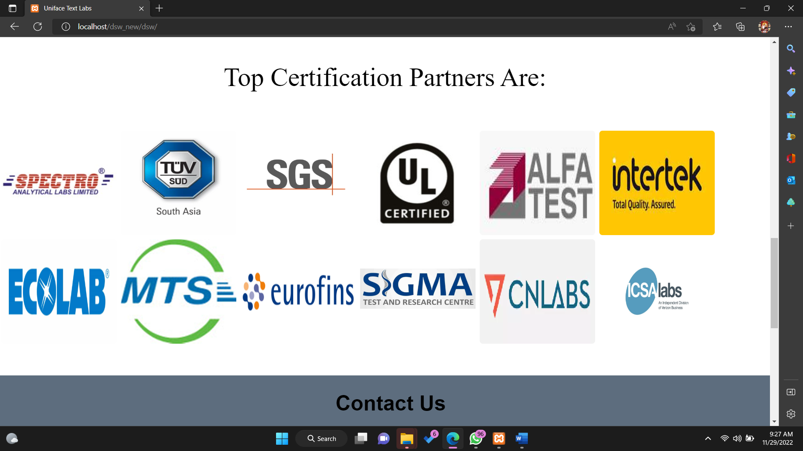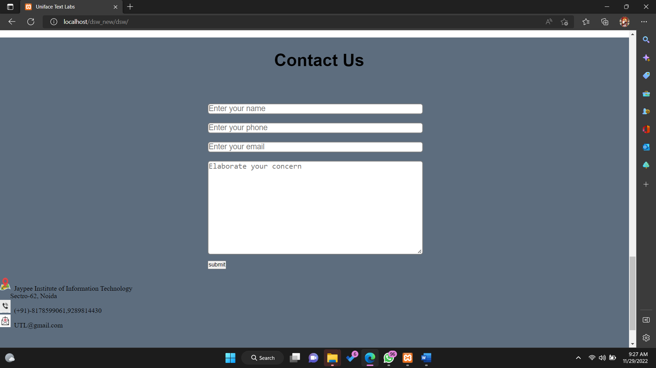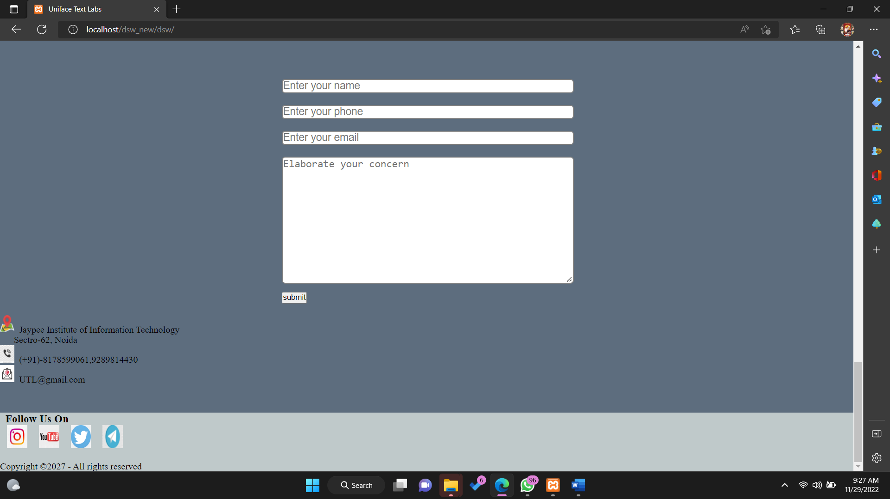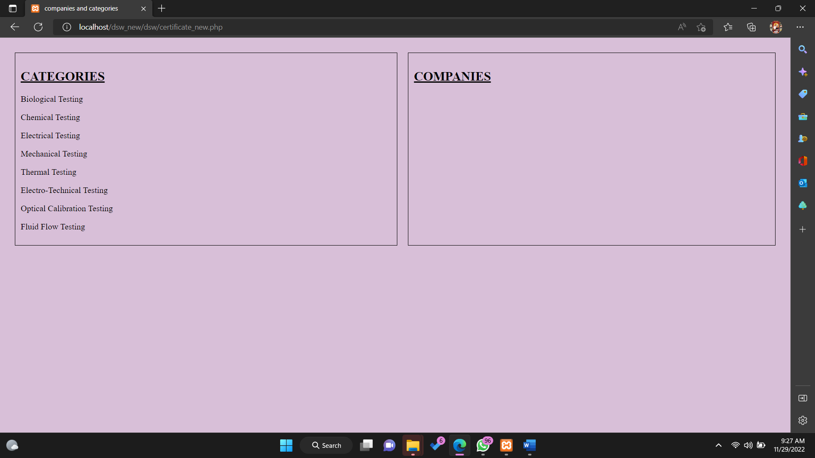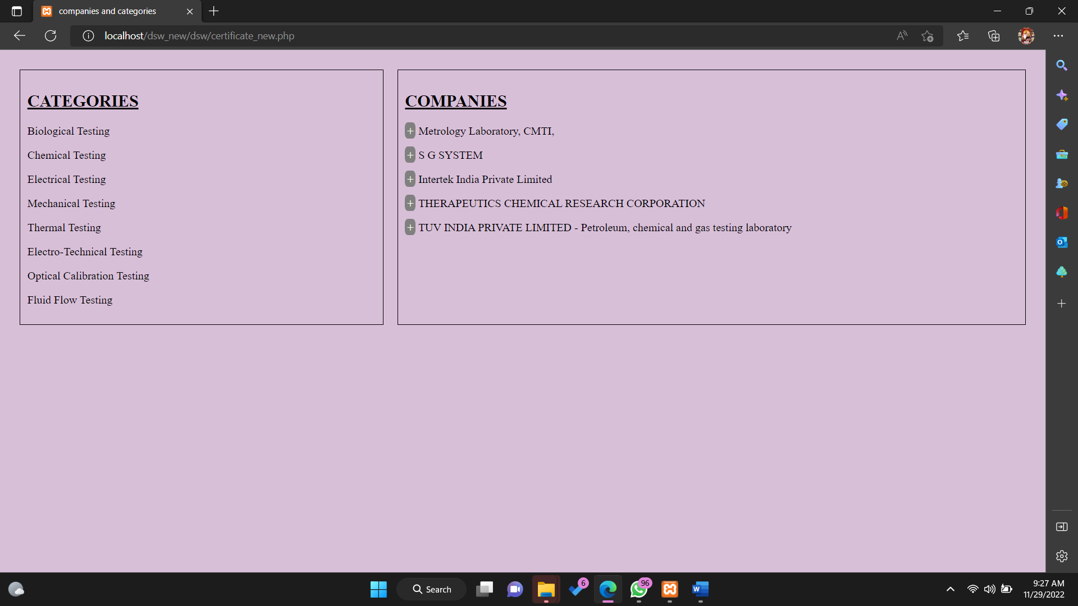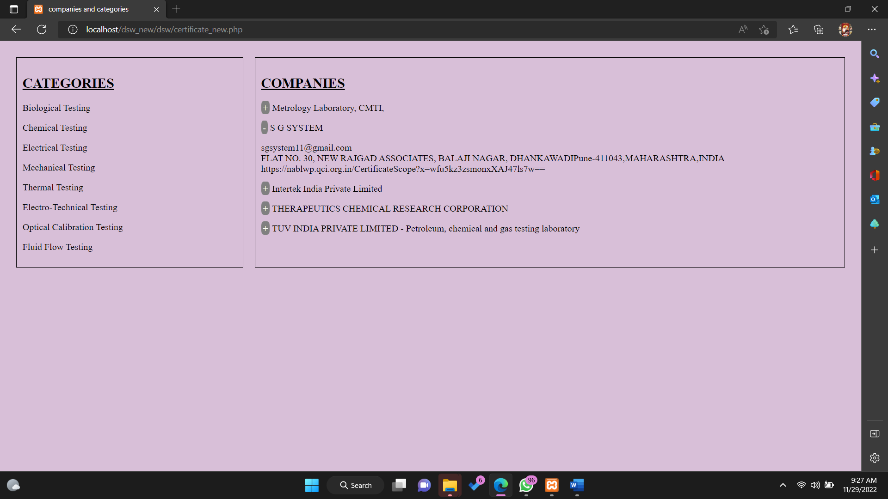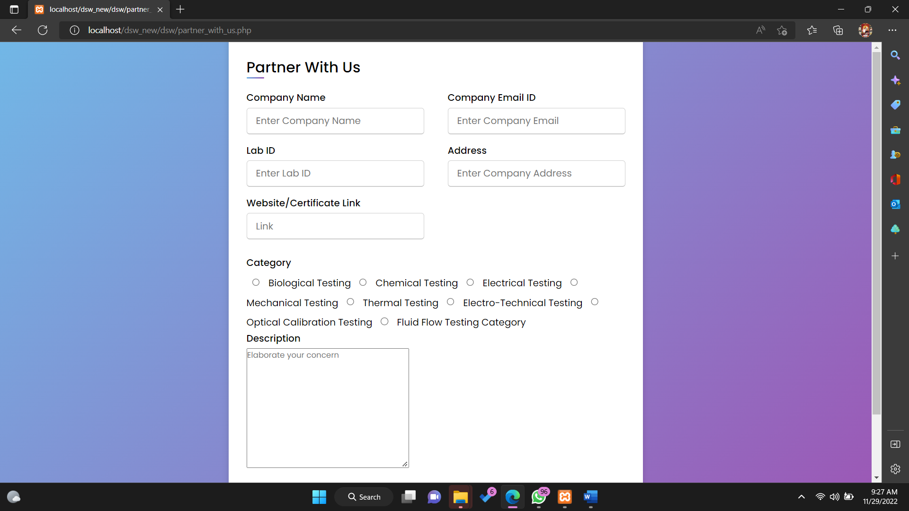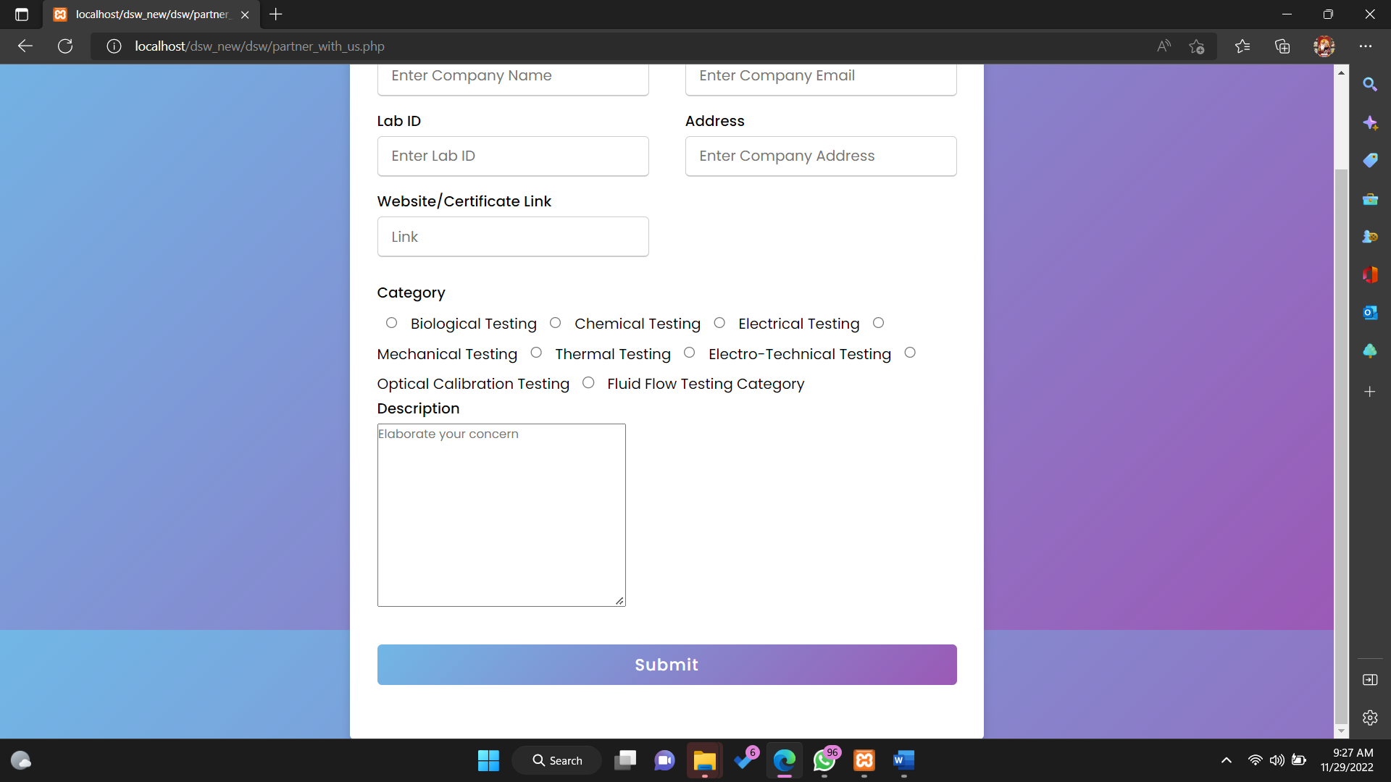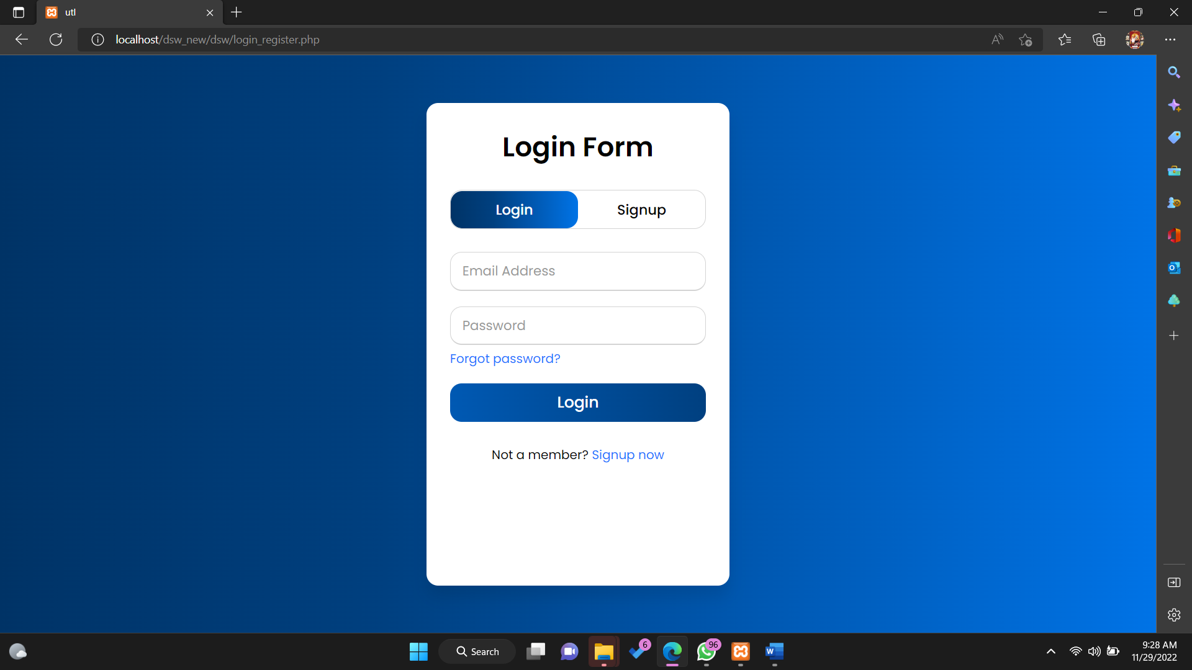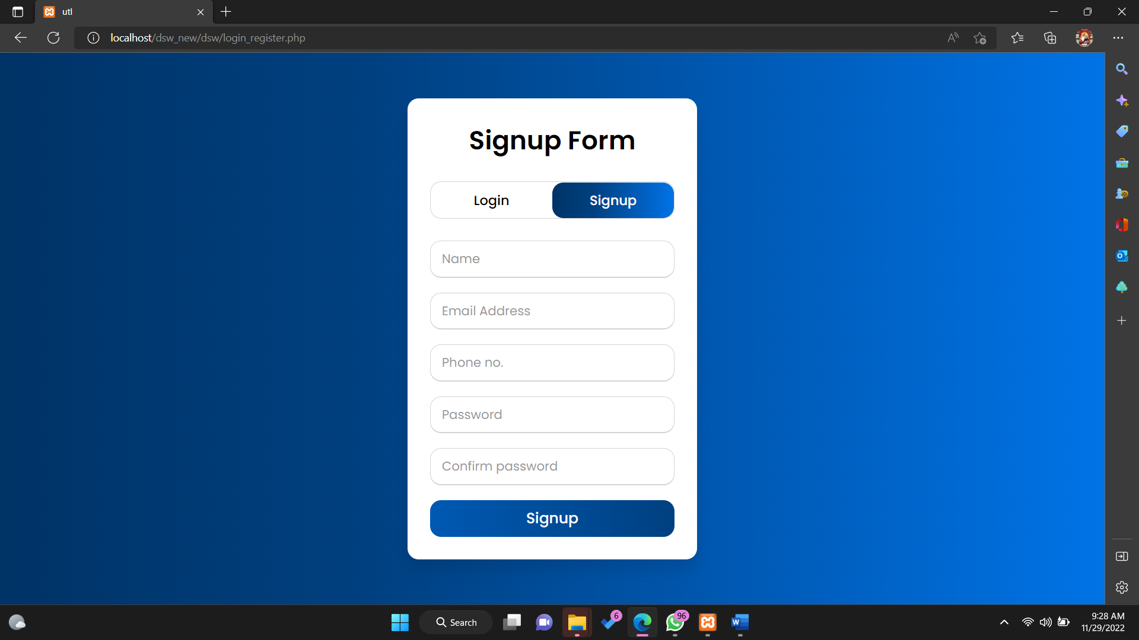

## *****Database *****

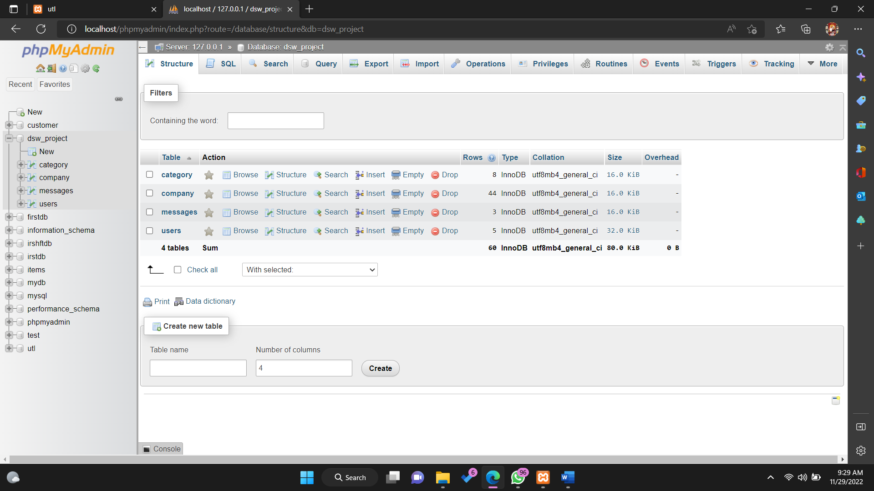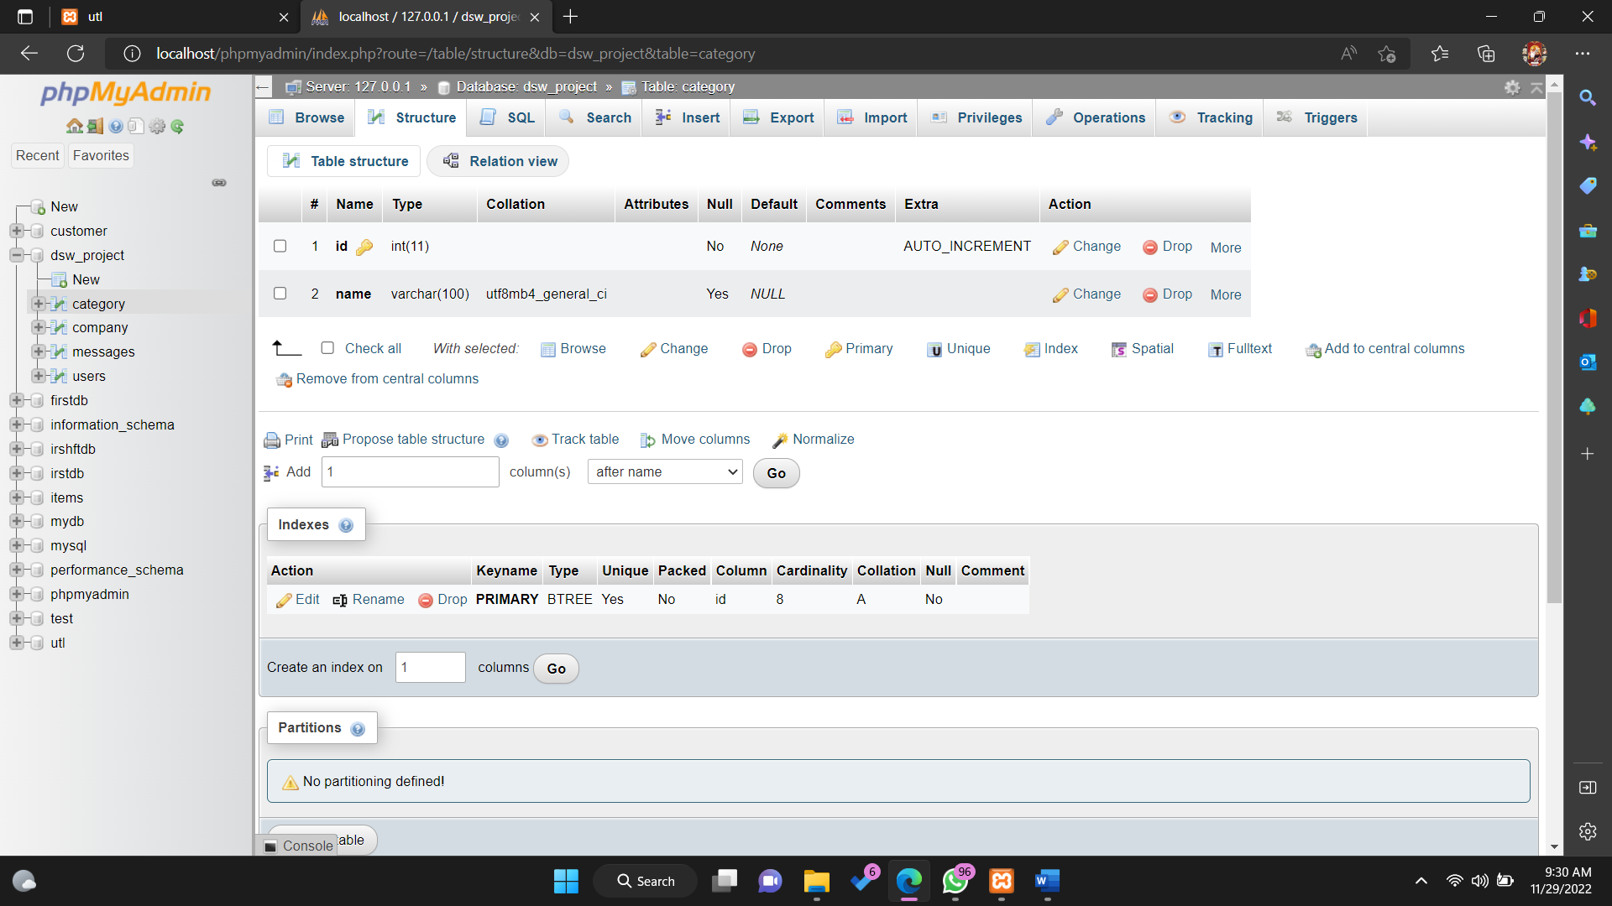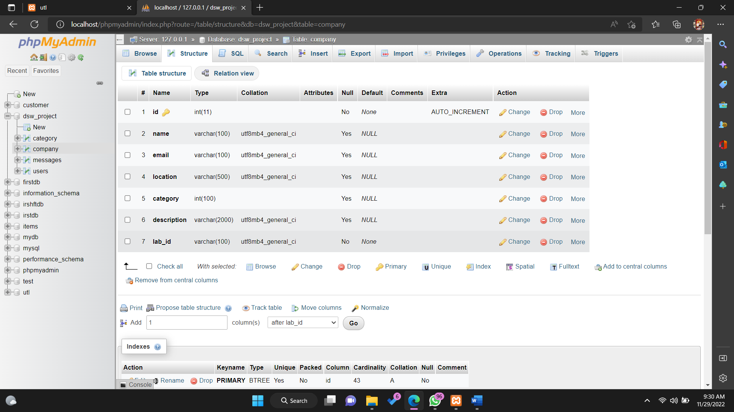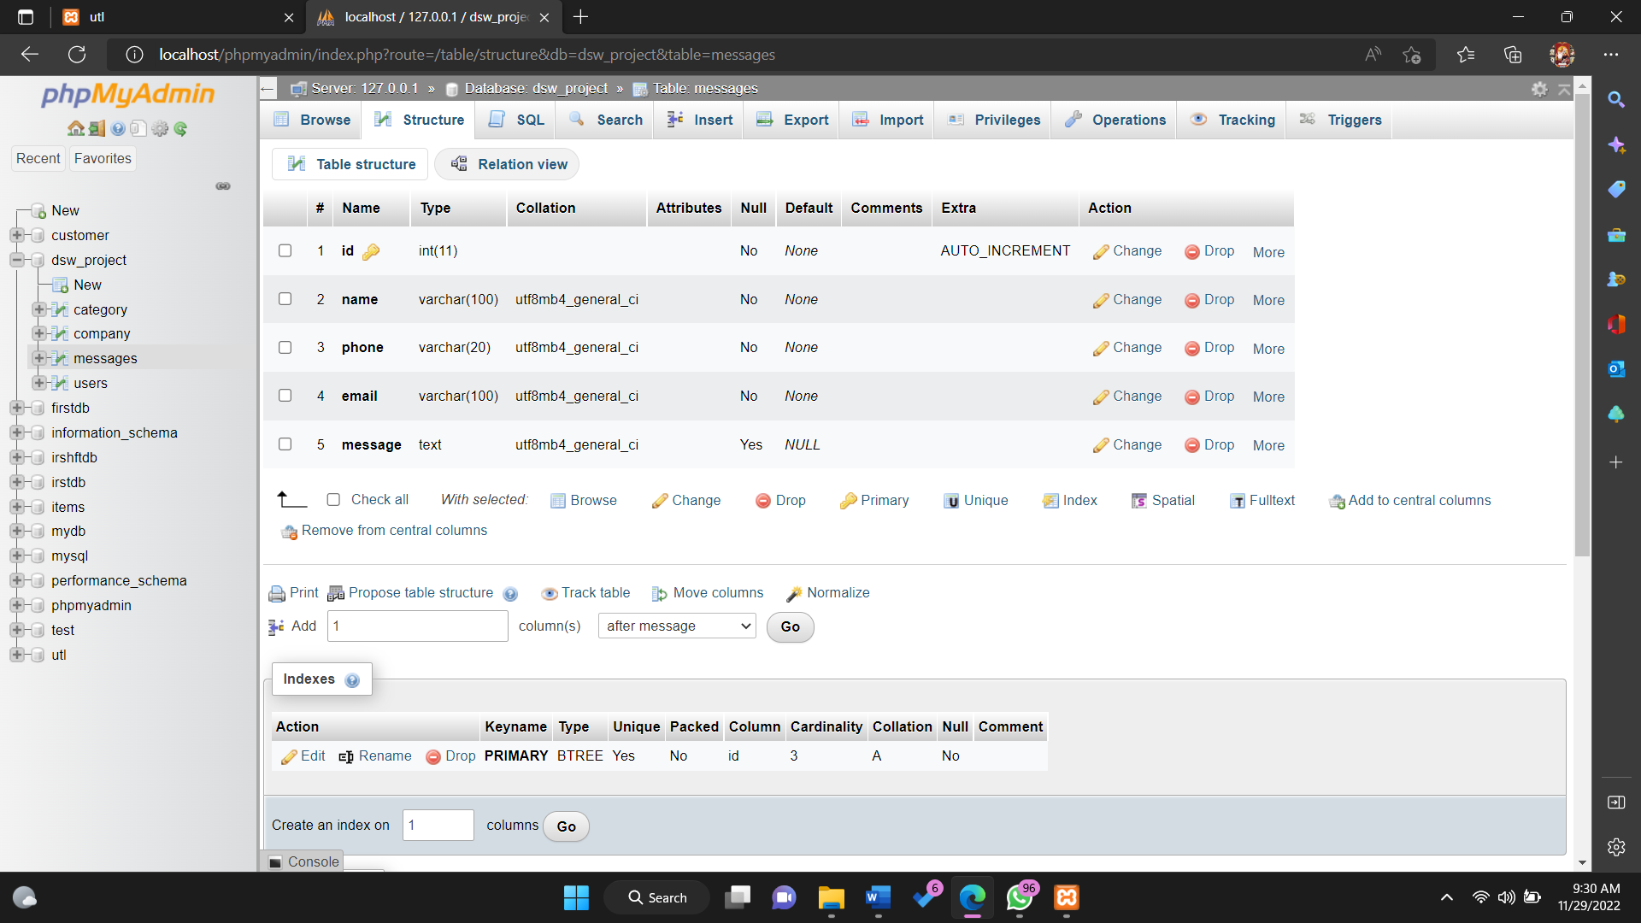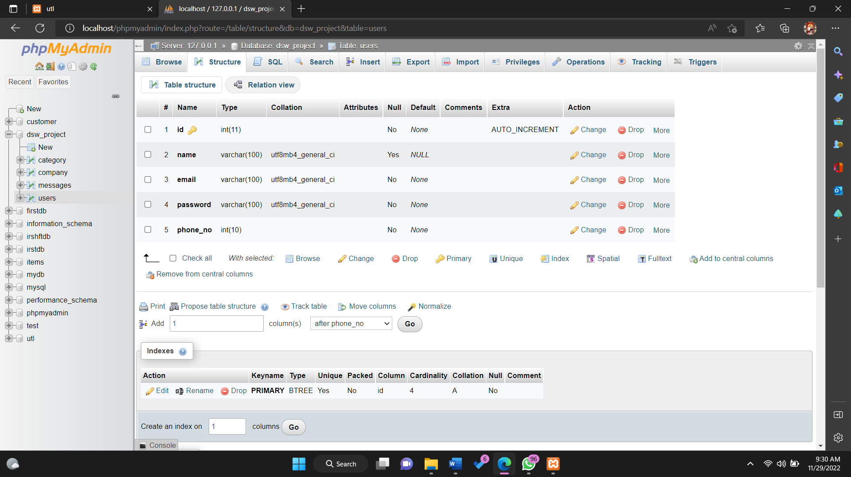

**Data in category table**

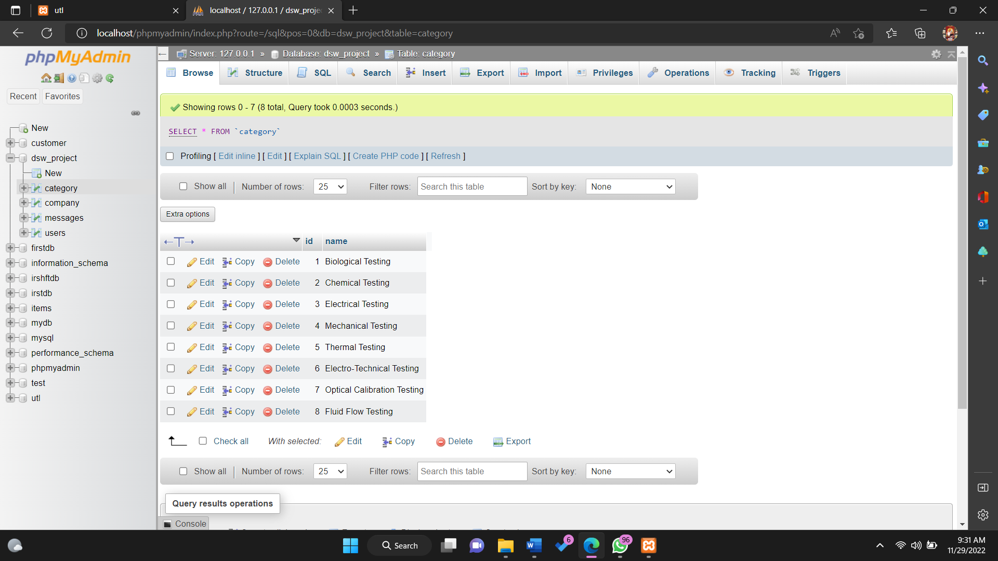

**Data in company table**

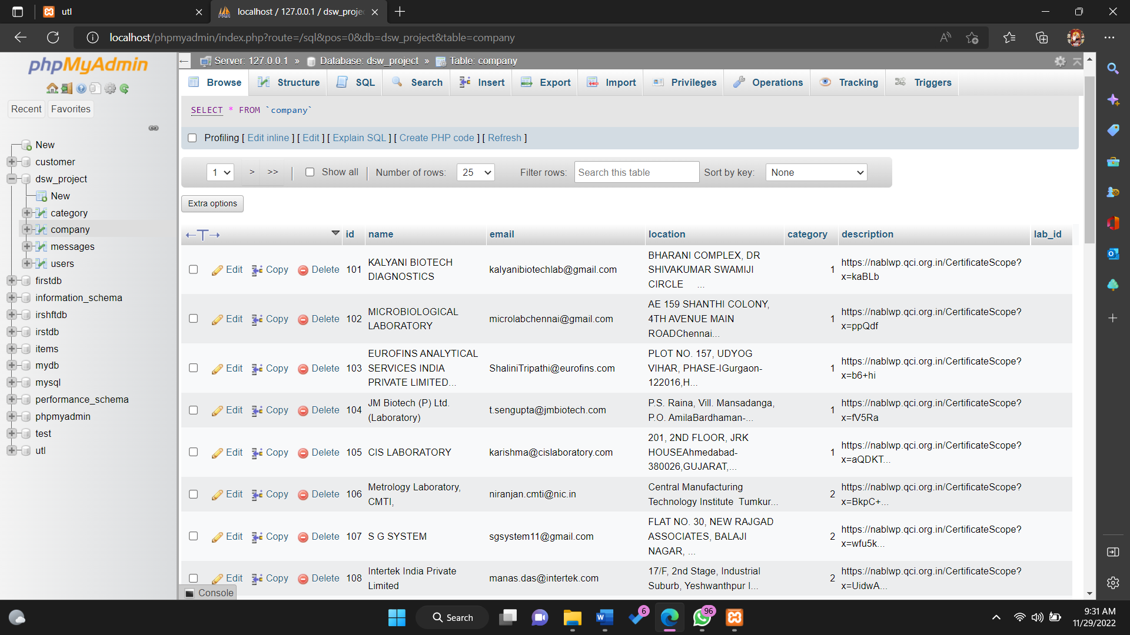

**Data in messages table**

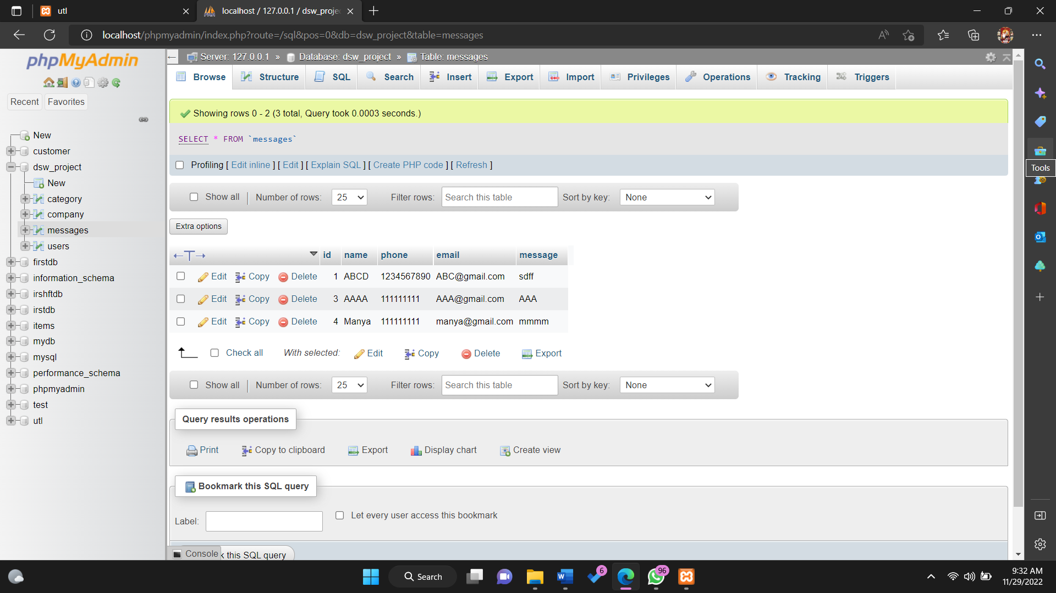

**Data in users table**

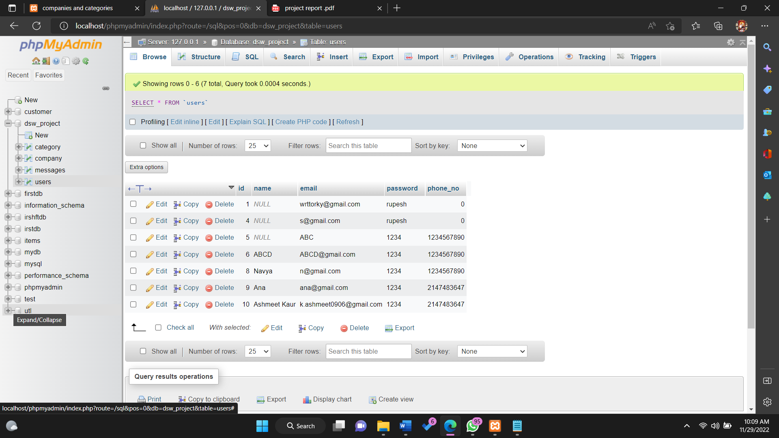

**\*\*\*\*Modules used\*\*\*\***

* DOCTYPE <!DOCTYPE html>
* html <html></html>
* head <head></head>
* body <body></body>
* span <span></span>
* p <p></p>
* div <div></div>
* sub <sub></sub>
* <input> class Attribute
* HTML forms
* <div> tag
* <img> tag
* <style> tag
* <script> tag
* <href > tag
* <a> tag
* <br> tag
* <input type> tag
* <img> tag
* <body> tag
* <title> tag
* <button> tag
* <form> tag
* <?php….. ?> tag
* <menu> tag
* <submenu> tag
* <nav> tag
* <ul> <li> tag
* <h1>…..<h6> tags
* Echo and print command
* If…else case statement
* Switch statement
* Import url statement
* <meta> tag
* <link> tag
* php-mysql connection
* alert statement
* prompt statement
* mysqli_query statement
* $_POST statements
* <span> tag